Picture shows how the tighter fitting I.D. of the enclosure acts as a “shelf” or a stop to keep the socket from backing out any further.

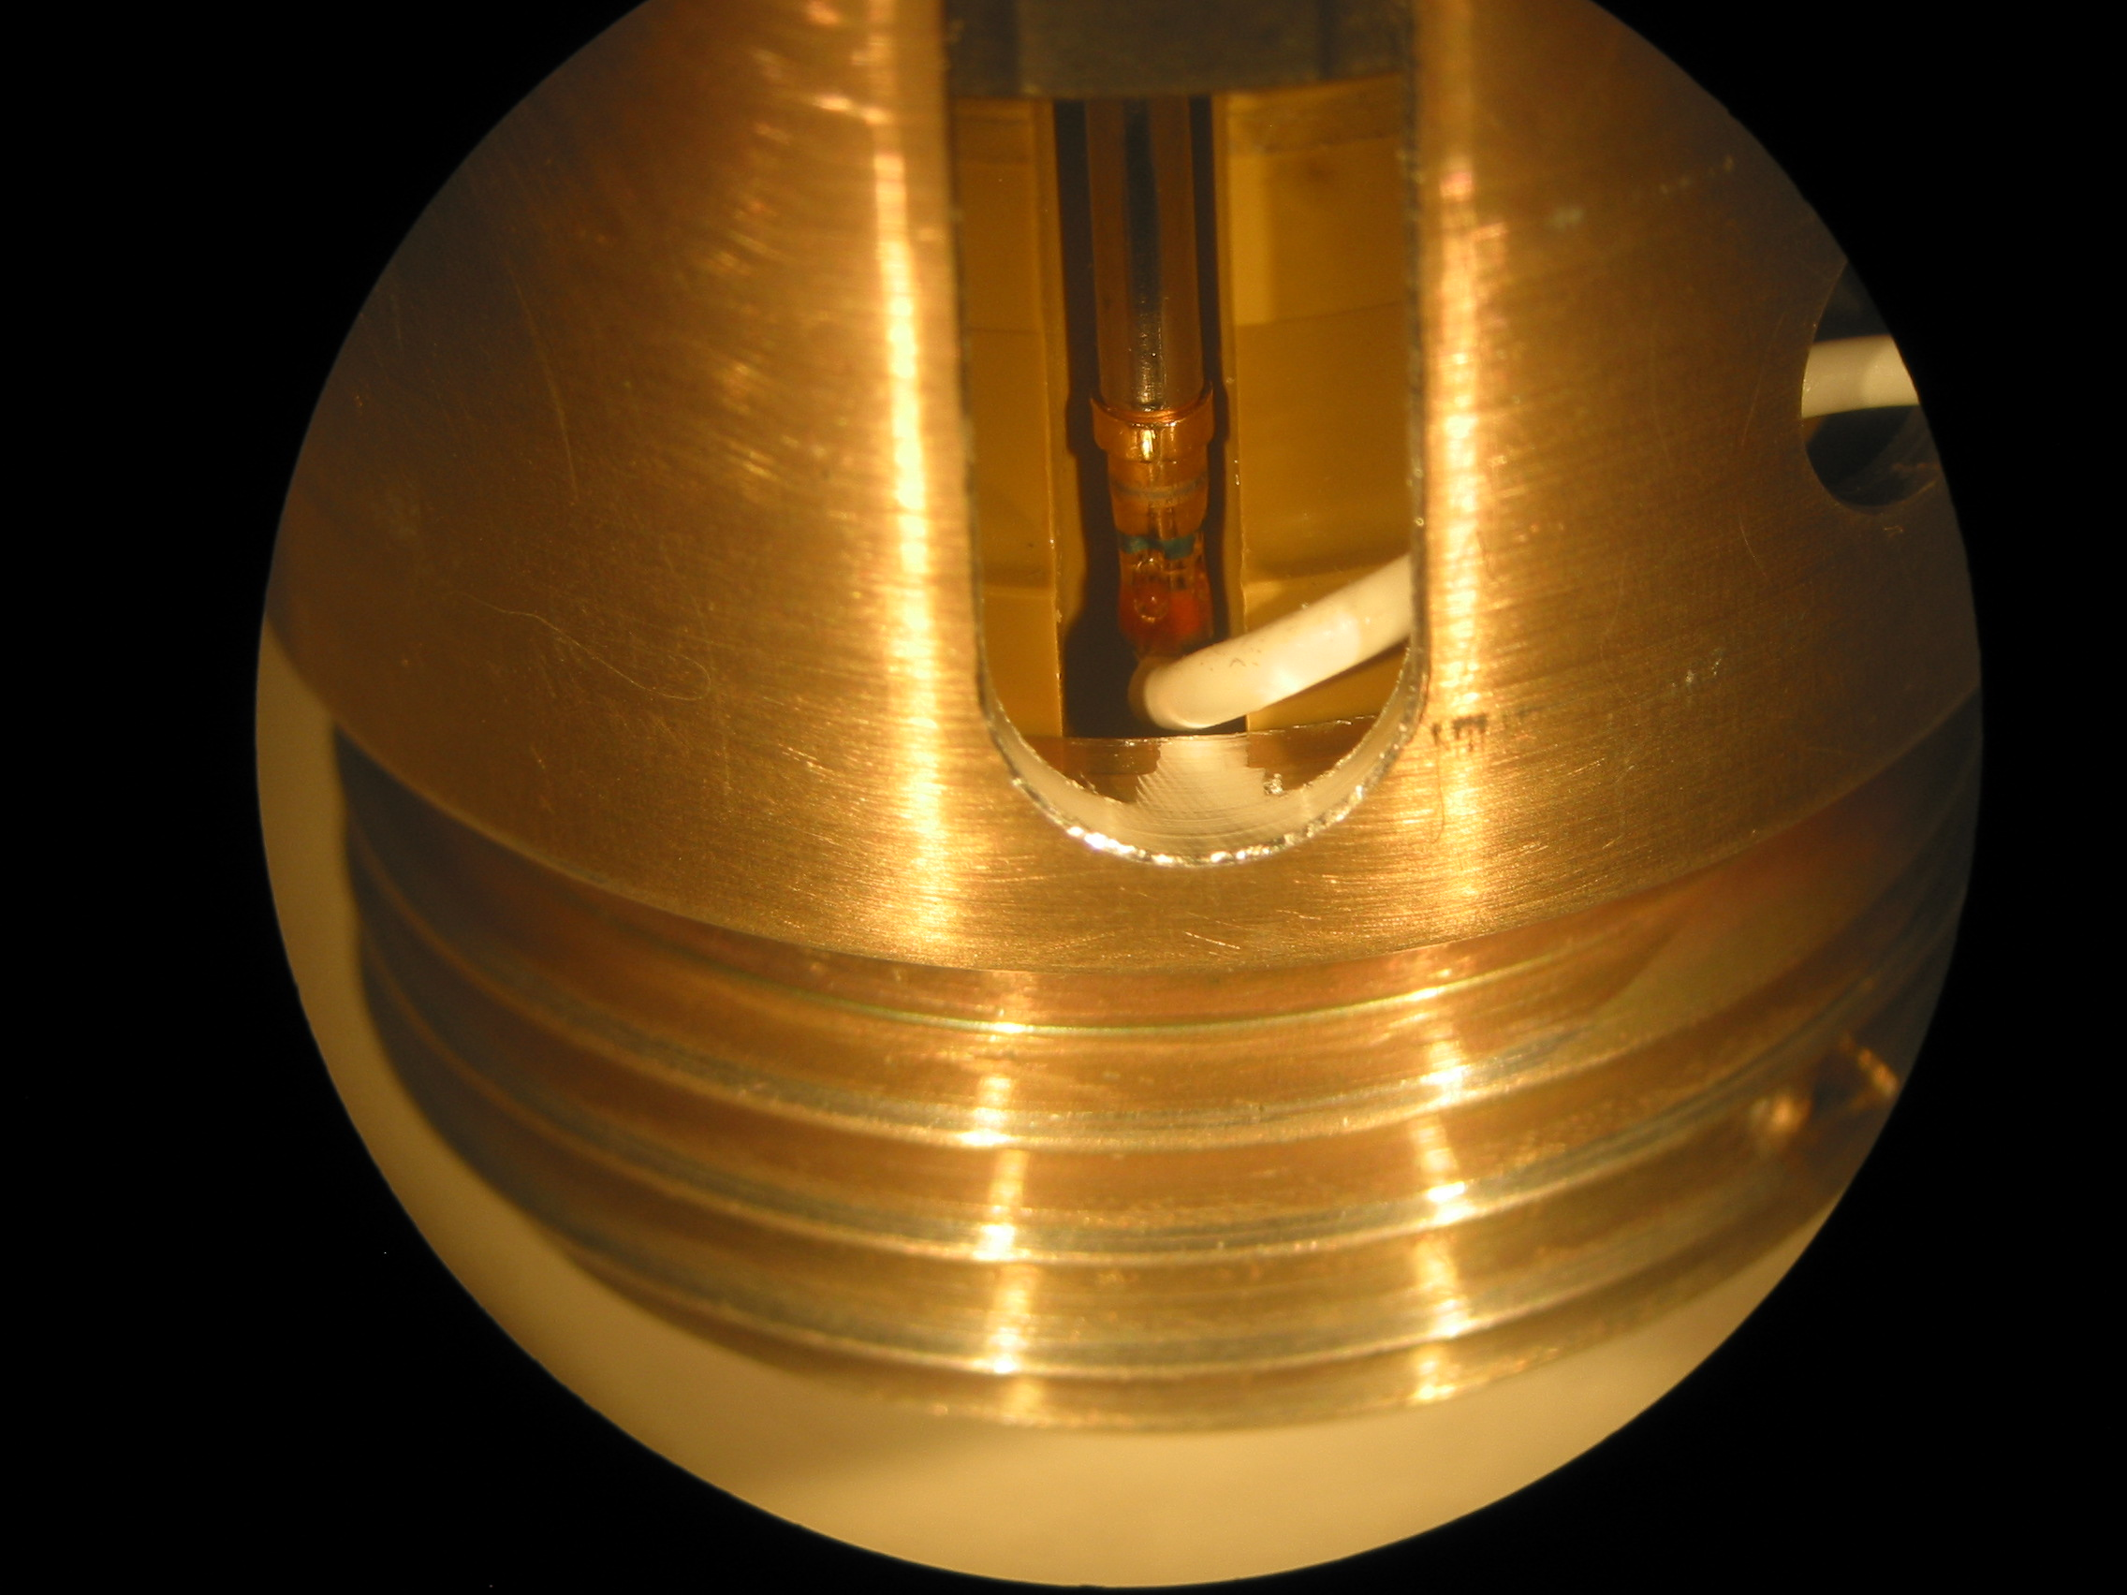

Lead Wire resting against this edge keeps the socket from being able to back out any further. This position corresponds to a minimum of 1/3 of engagement remaining = 0.100

Bottom of lead exit hole (even with no grommet) is 0.125” above the “shelf” so manipulation of the wire from the outside can not cause things to get worse.

