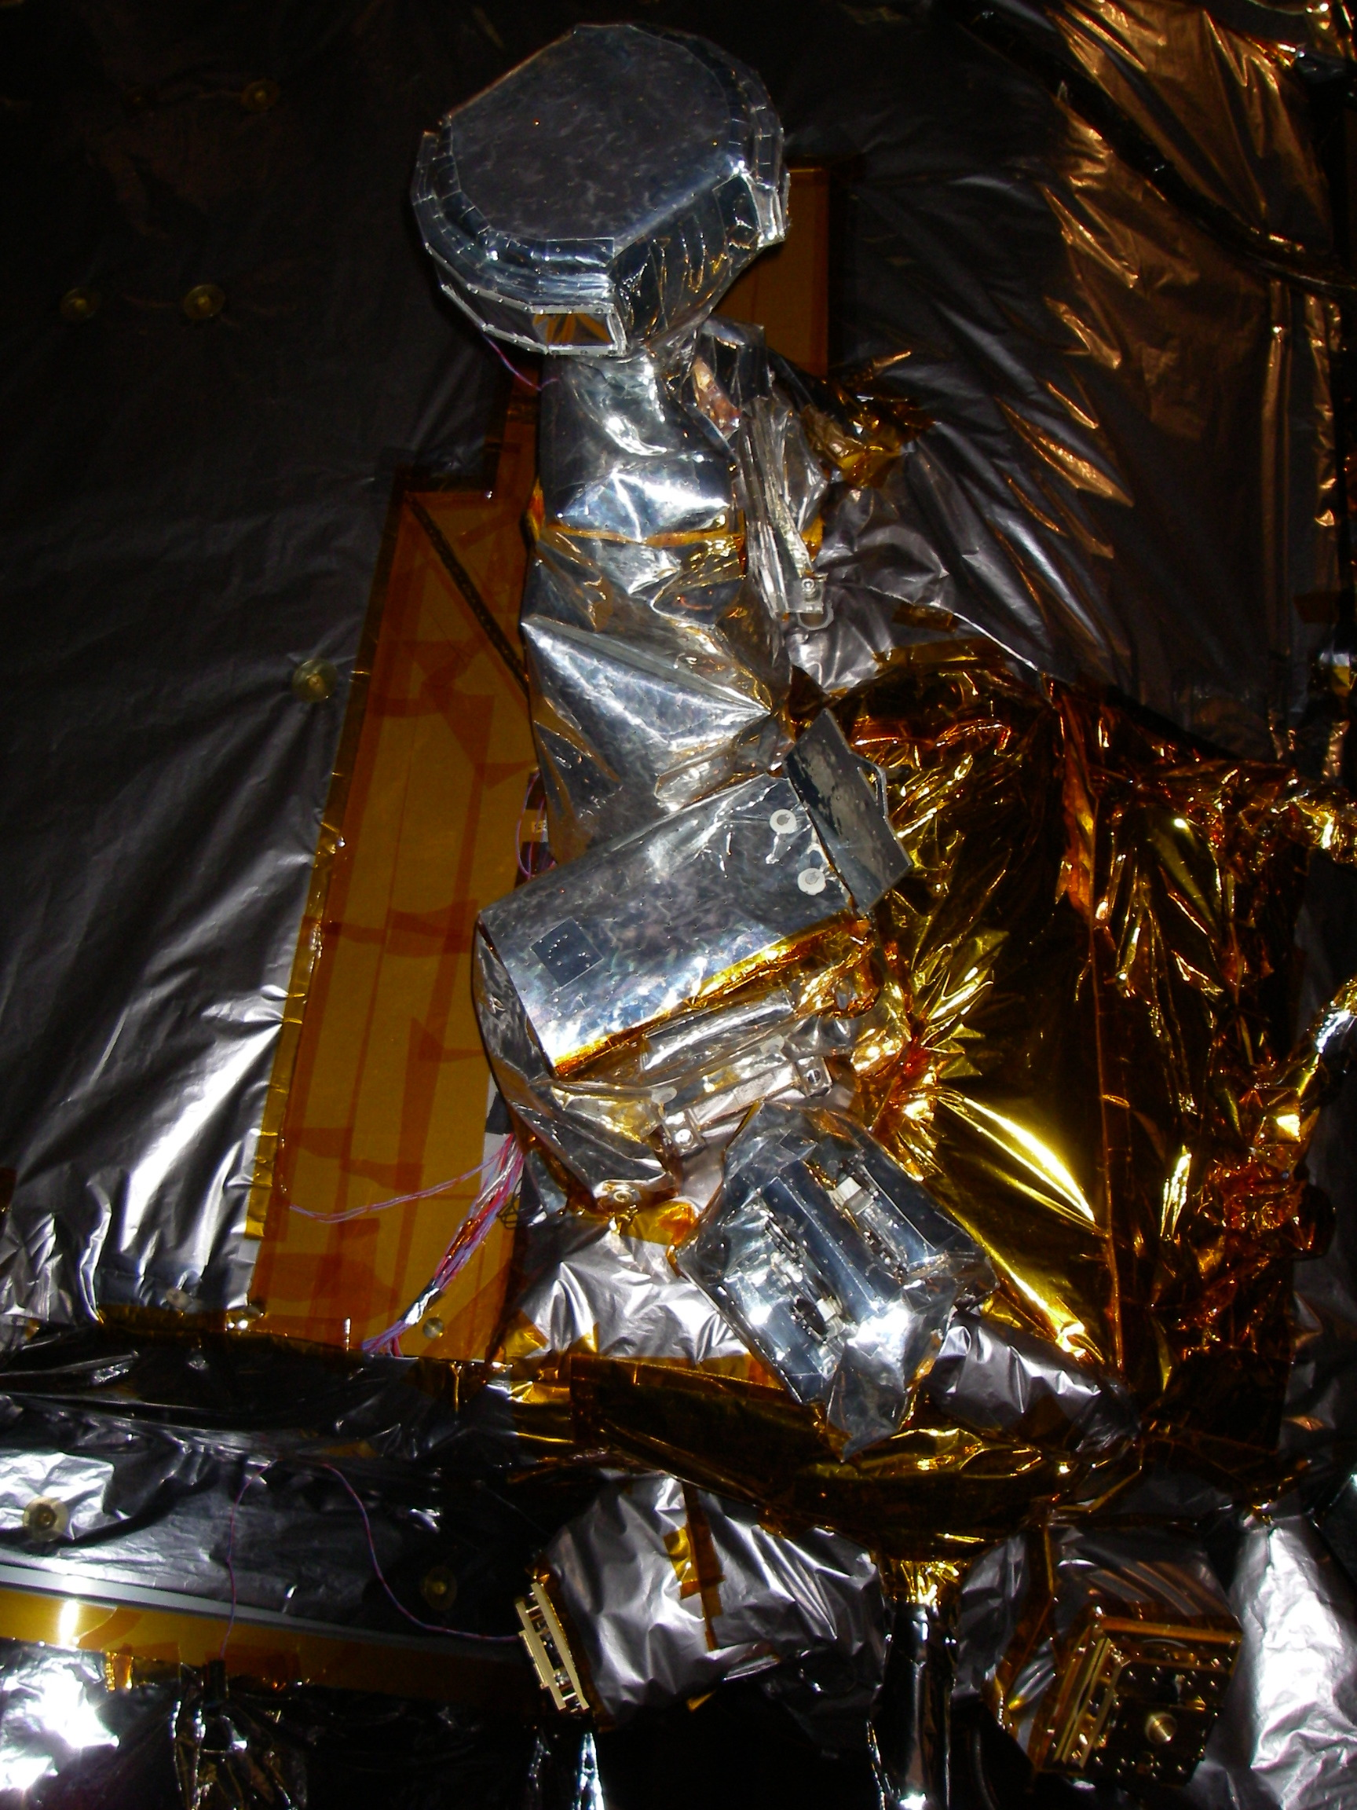
These doors are still open.
SIT door
LET

These doors are closed.
Spacecraft A

