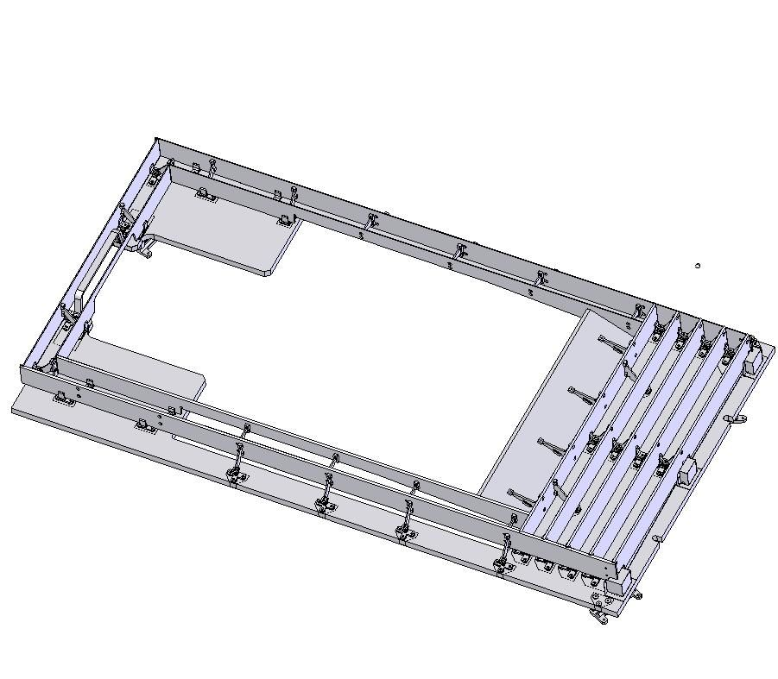
Outside baffles
Inside Baffles

