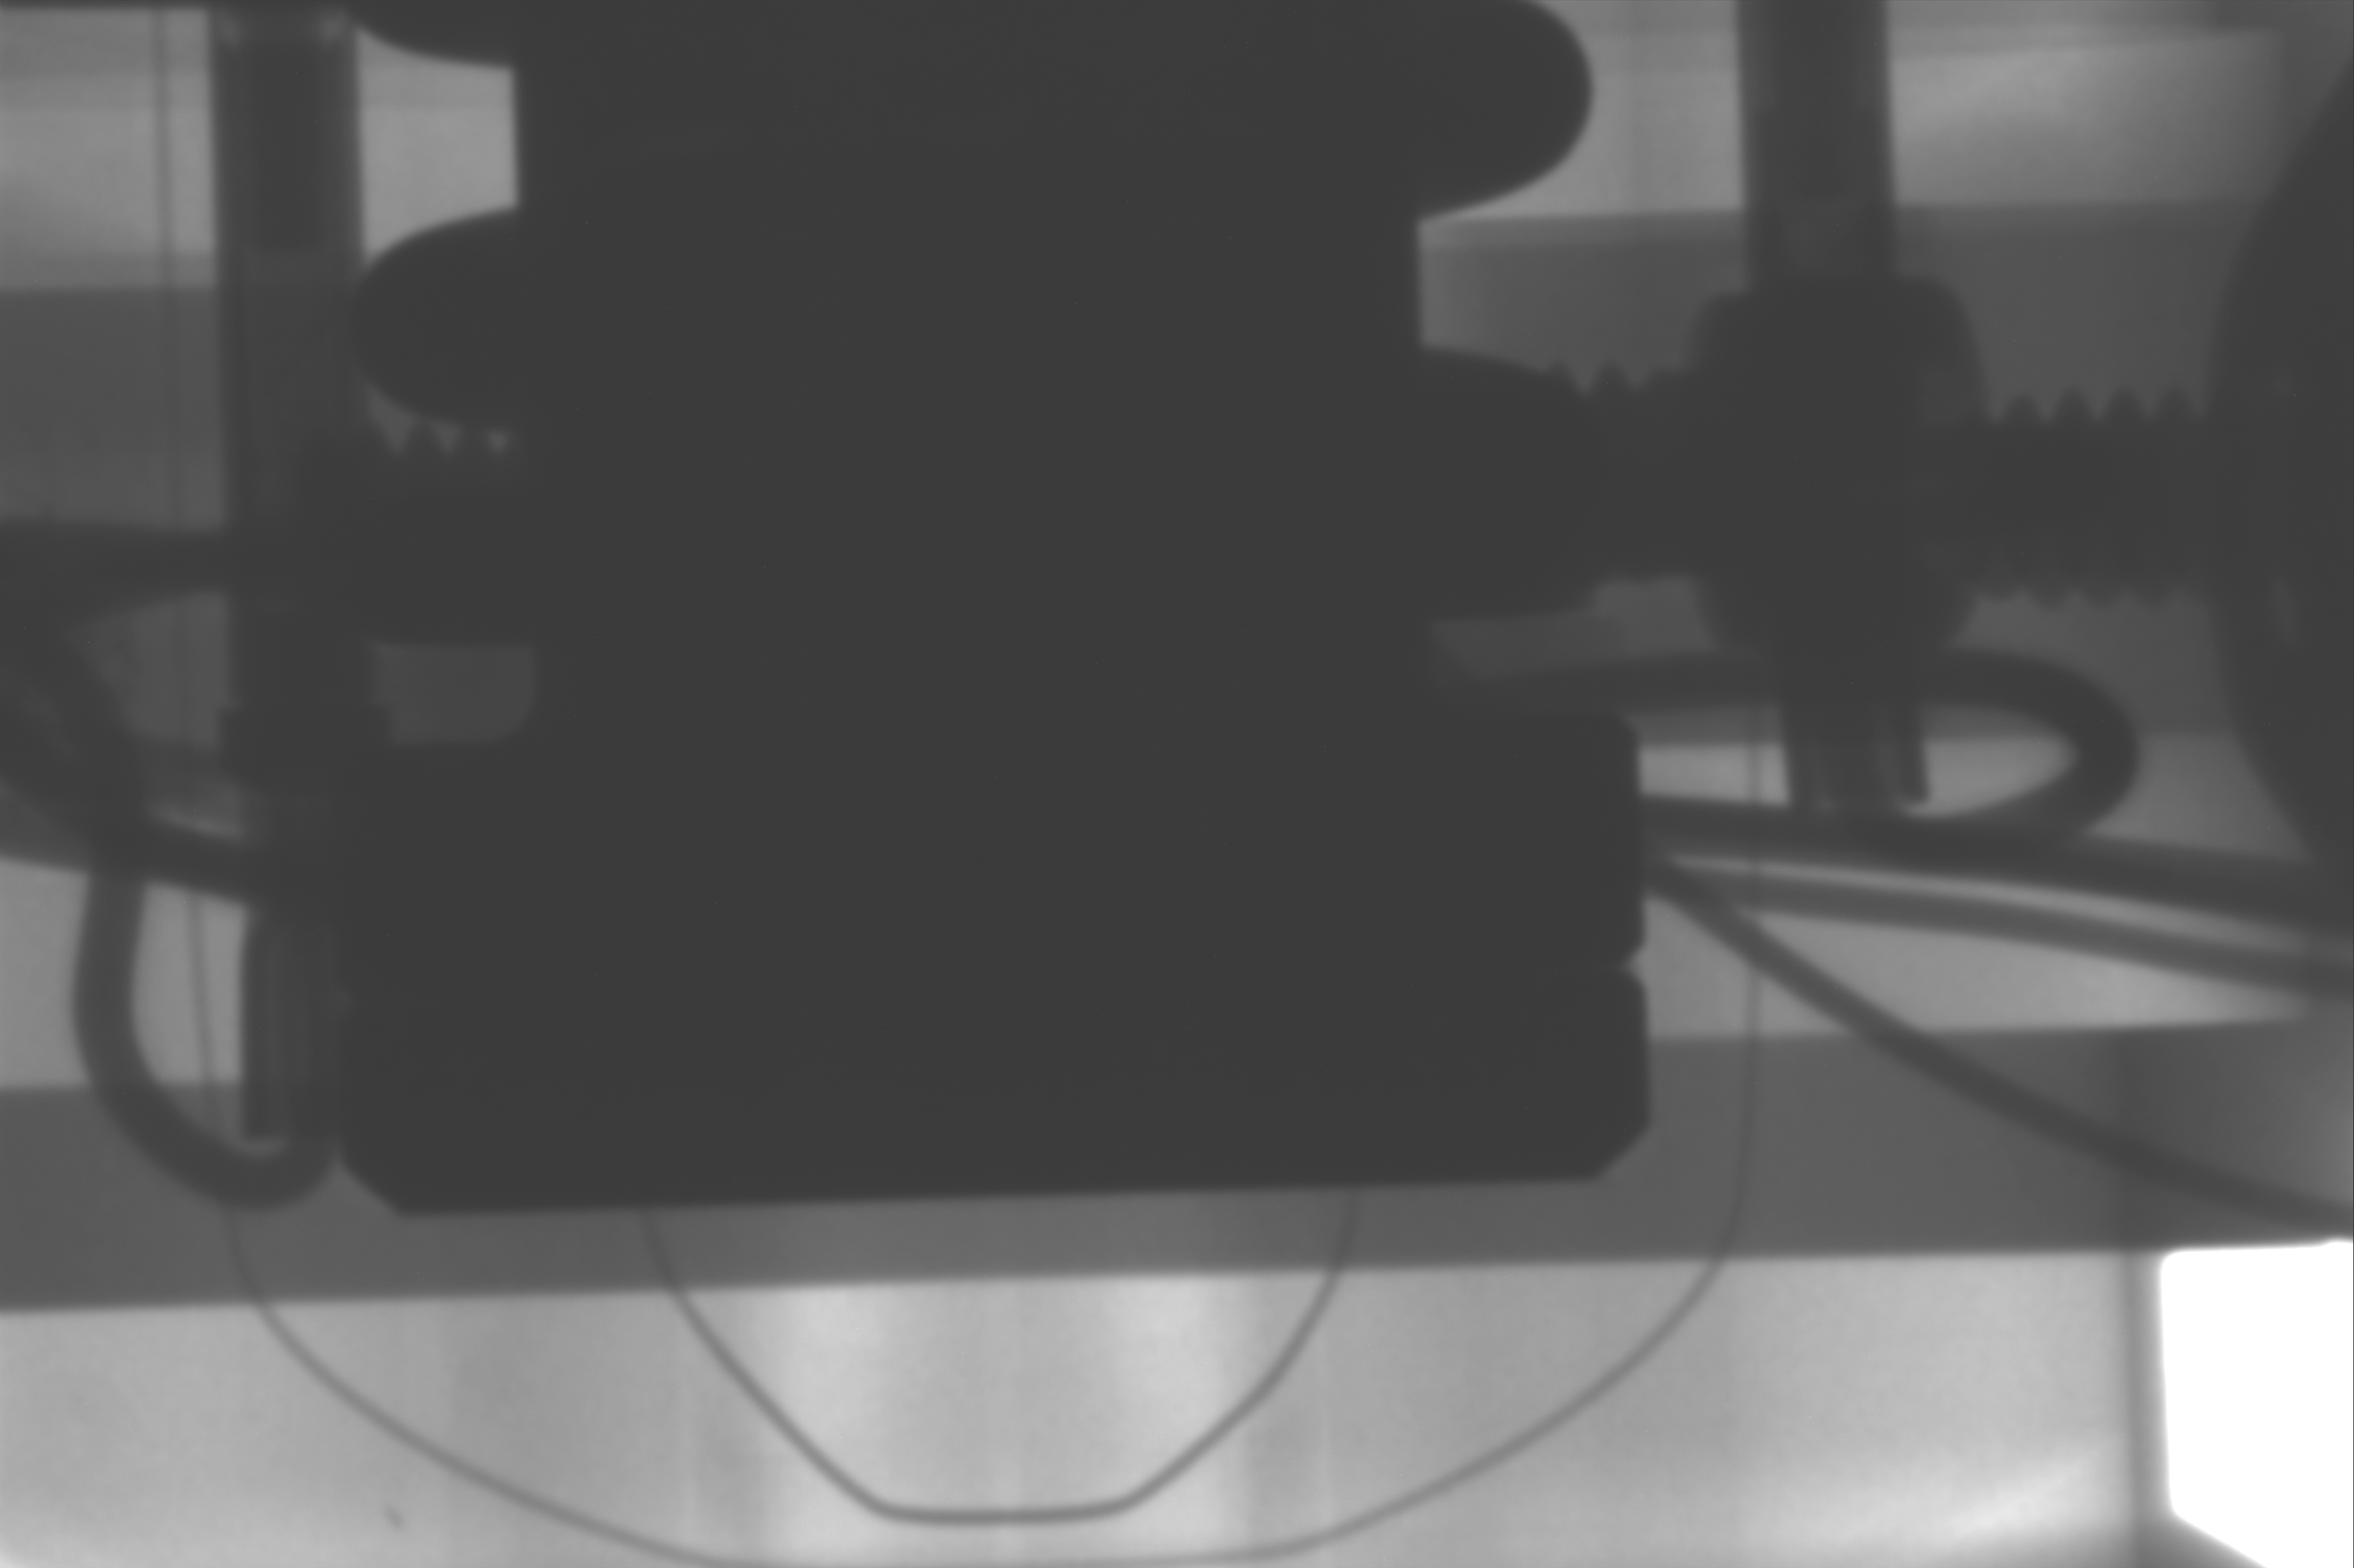
locking shoulder
locking shoulder
Note difference in heights of locking shoulders
end of pin

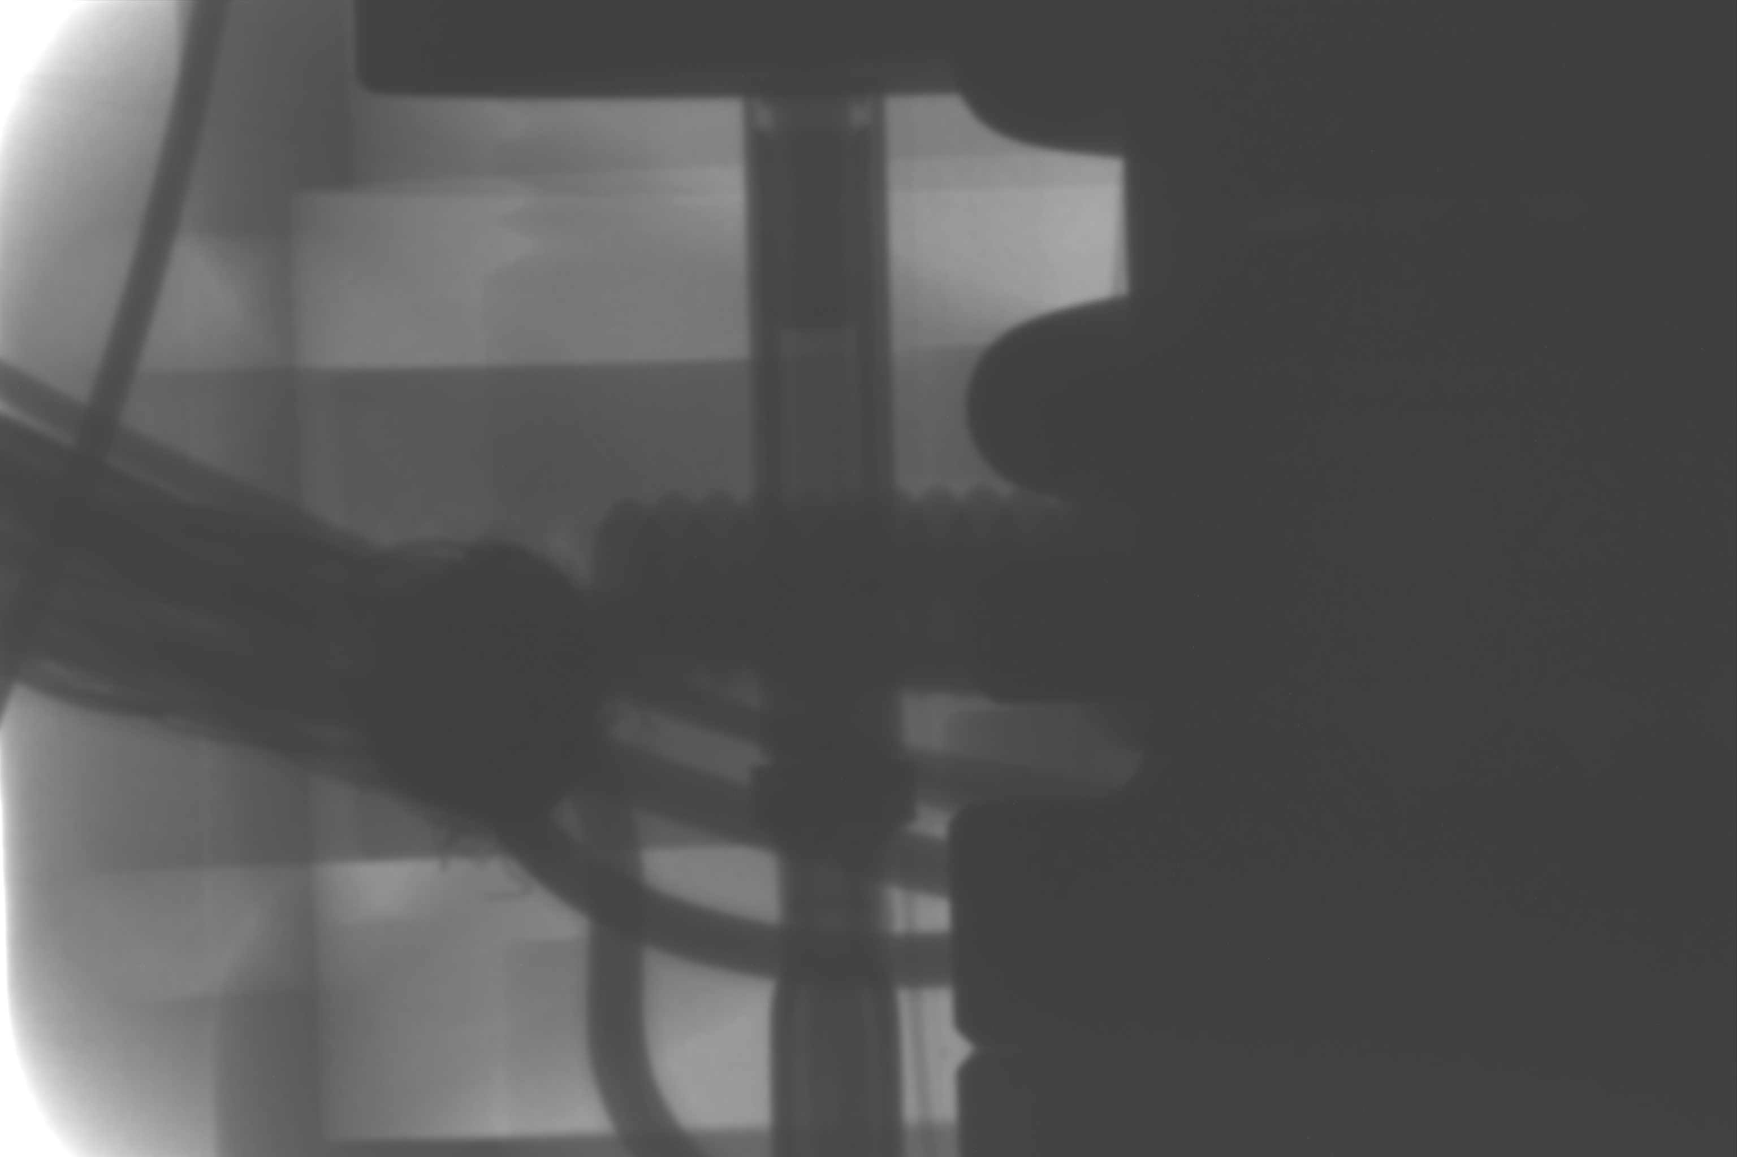
top of socket near here
start of retaining feature
end of pin
locking shoulder

