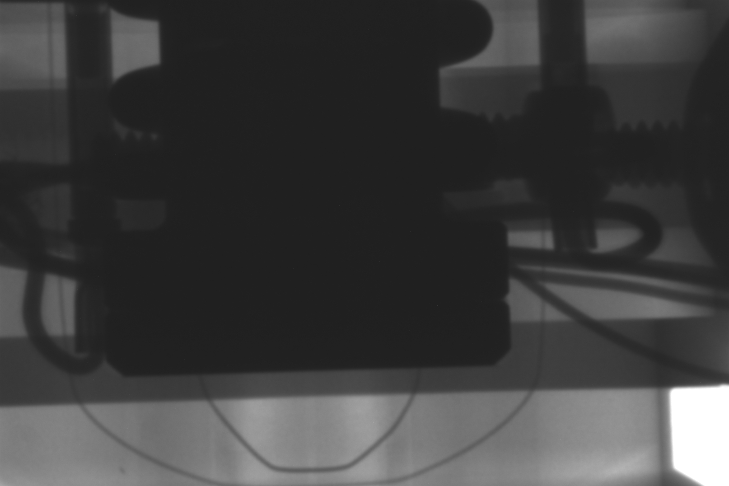
Bottom of
Sleeve

Socket As it Should Be
Socket As it Is

X-ray showing the socket on the left is lower than it should be such that its lead end is just above the bottom of the pin (or aligned with the end of the chamfer).

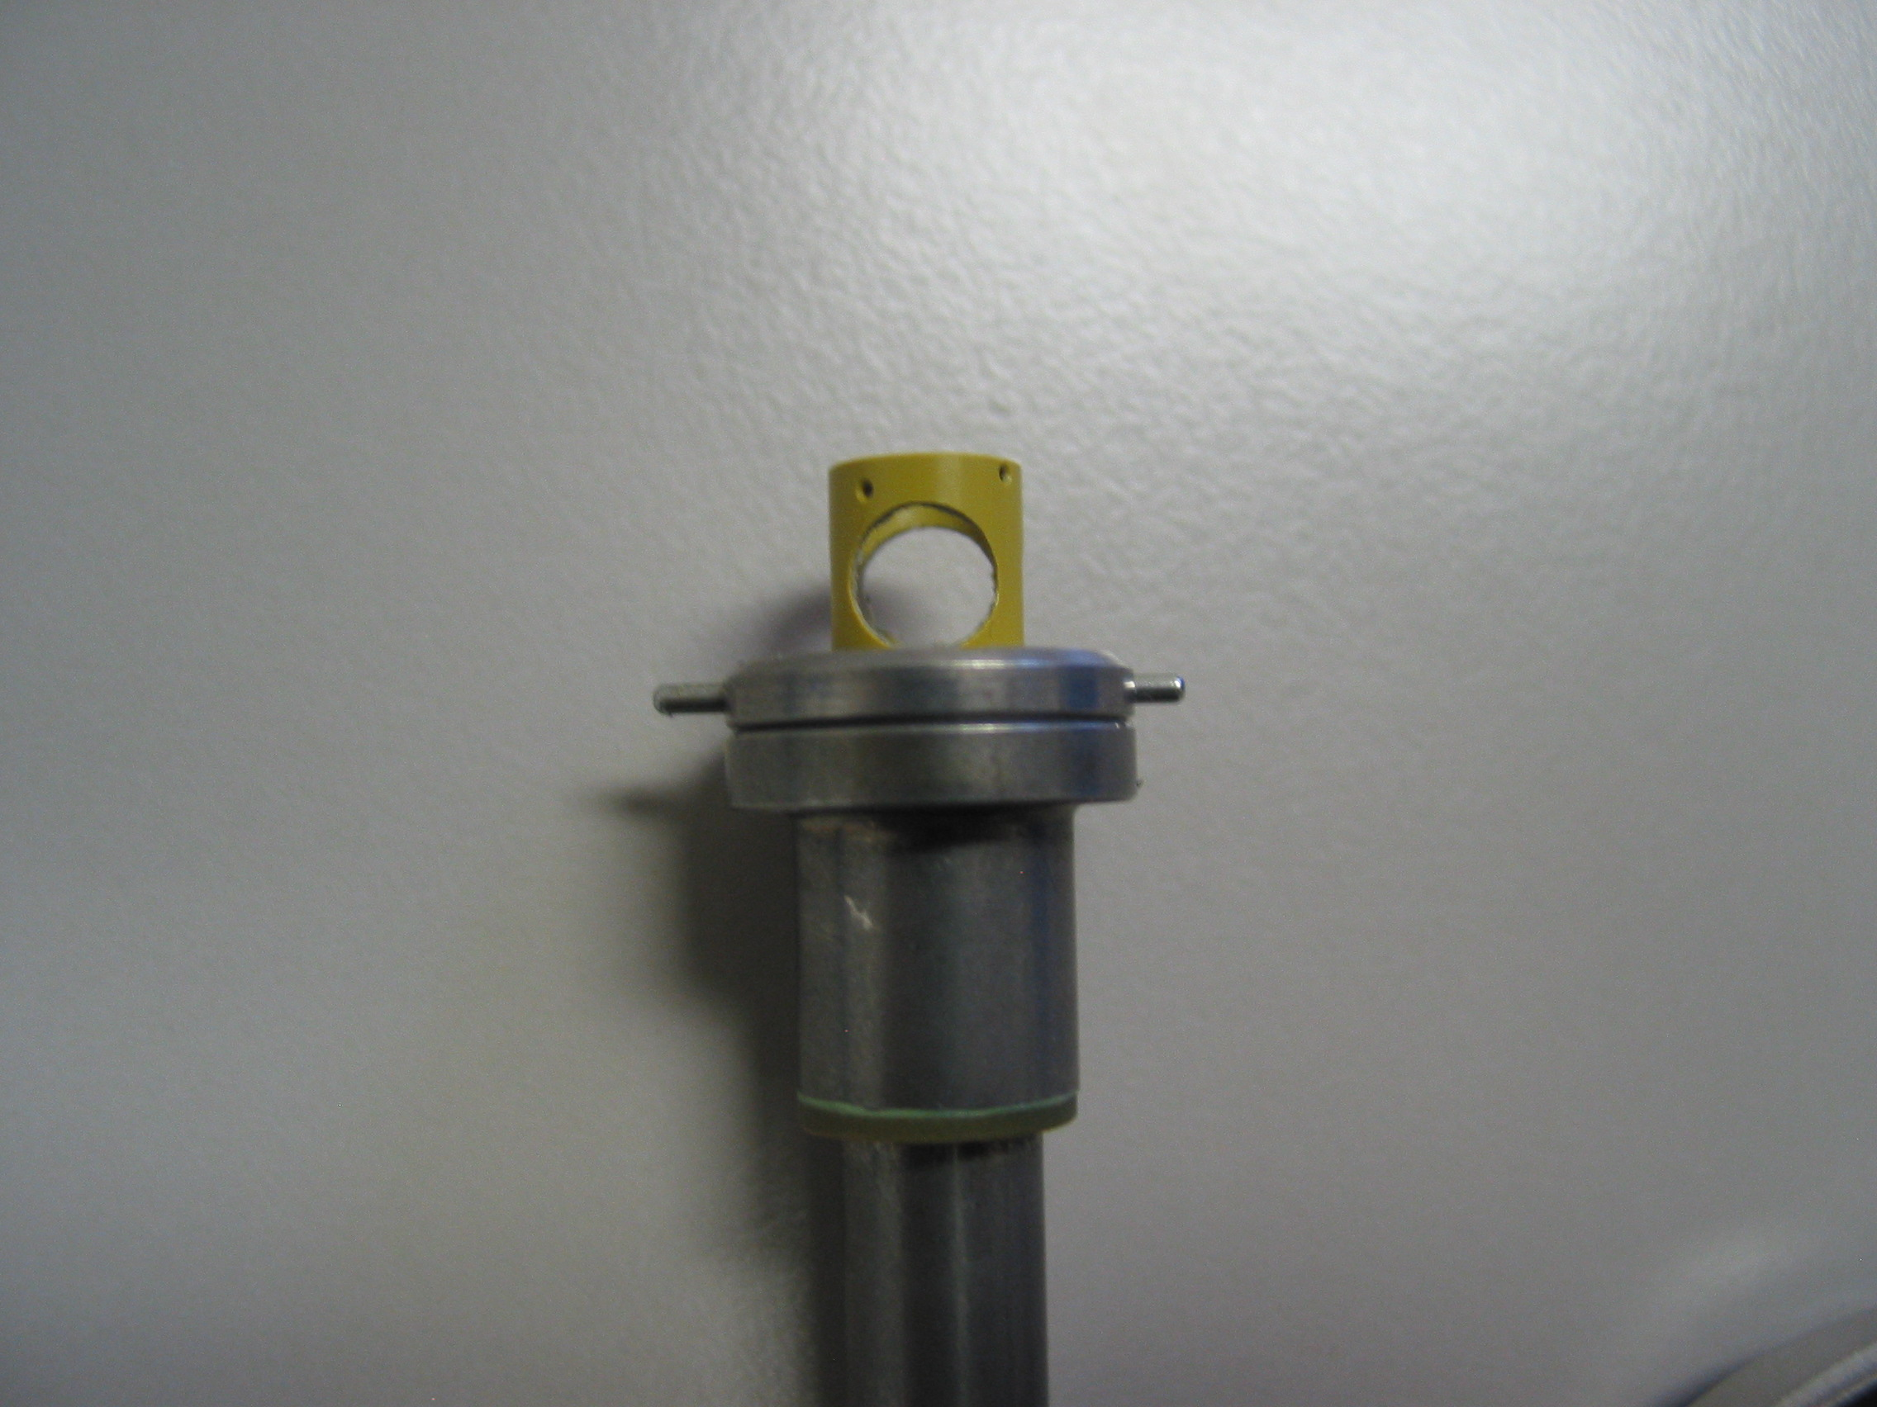
Bottom
Of Sleeve
Used as
Frame of Ref.

Picture of actual part…
End of the Chamfer corresponds to where the cross pin is located
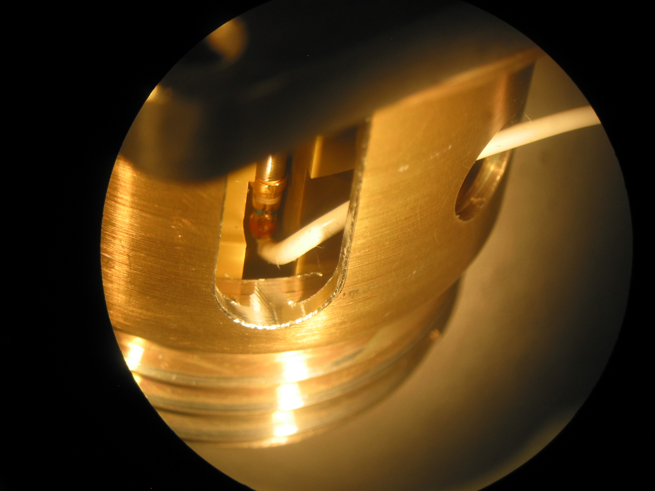

This is the tighter fitting bottom section of the enclosure. The wire can not go between these 2 parts. Also note the relative position of the lead exist hole.

Test enclosure was slotted to show narrow region which helps keep the wire from backing out further….

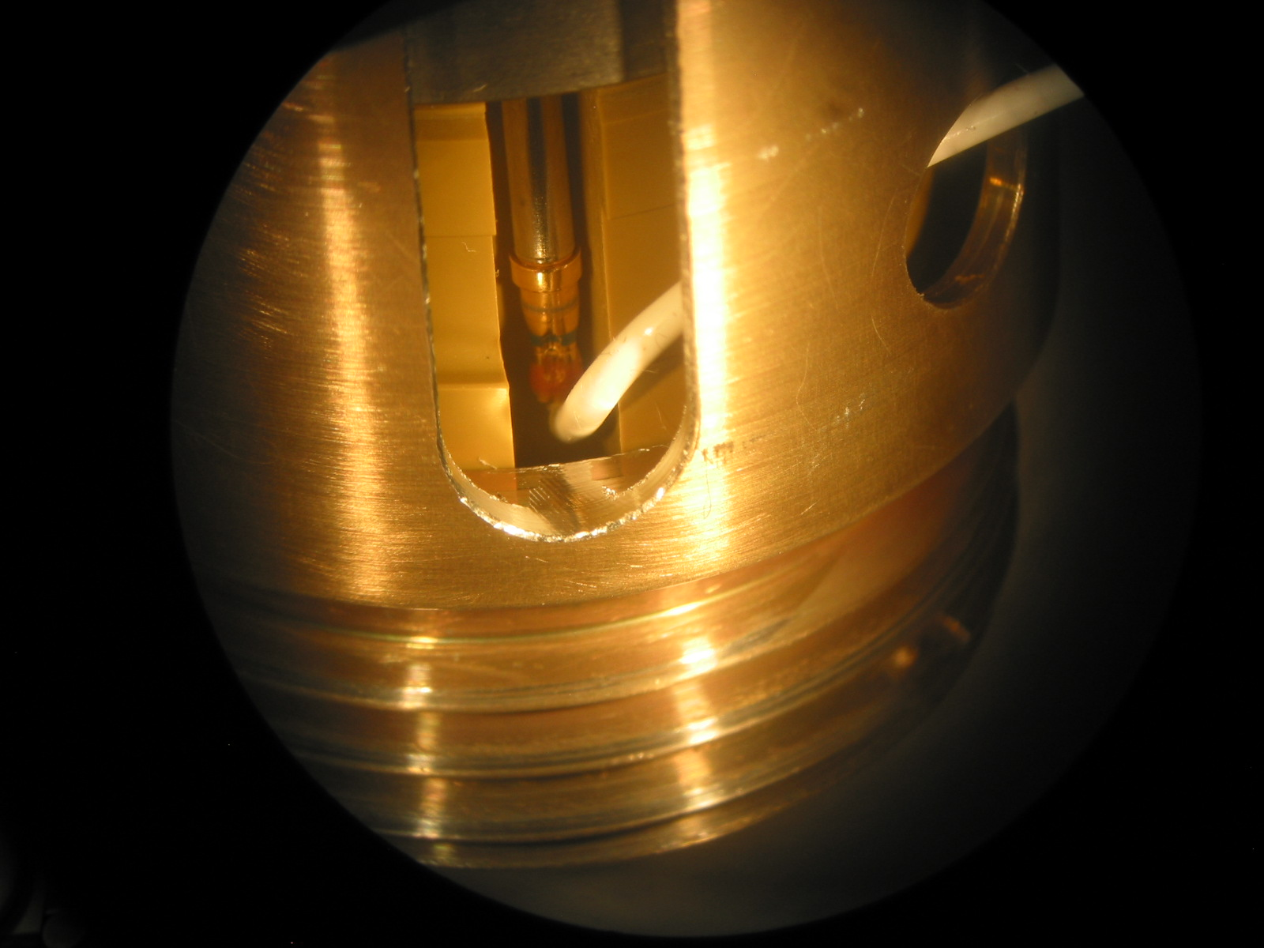

Socket can be seen to reside in local cavities which keep from moving
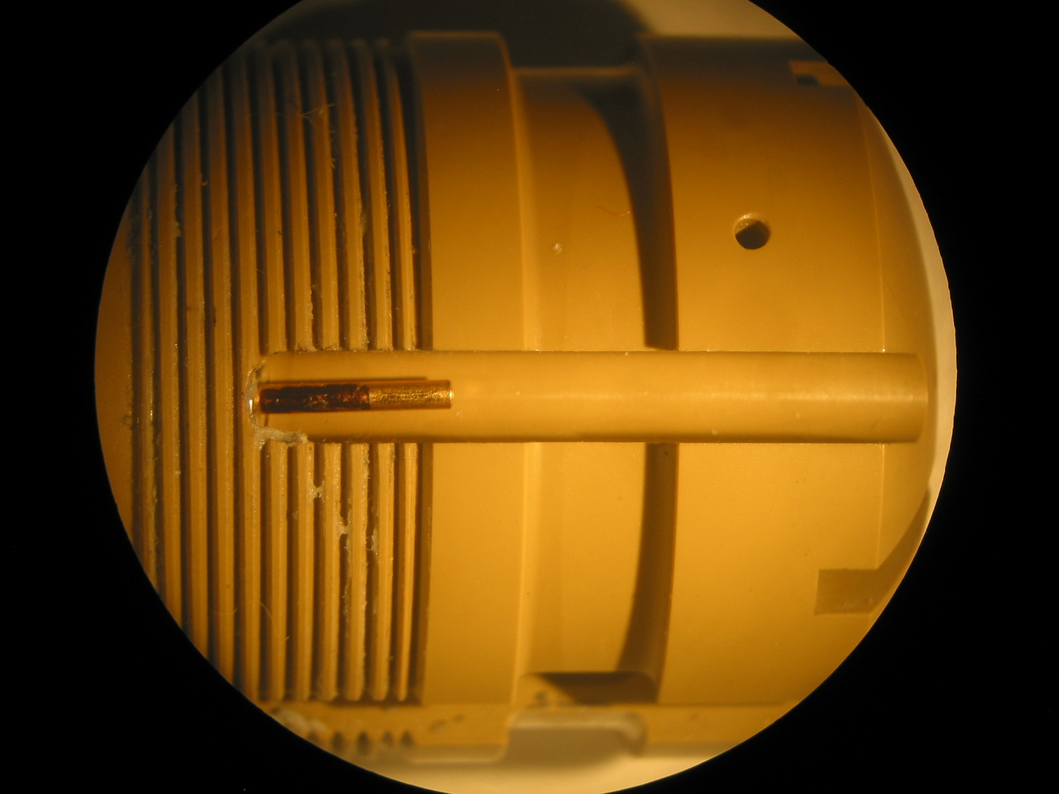

Portion of Pin engaged

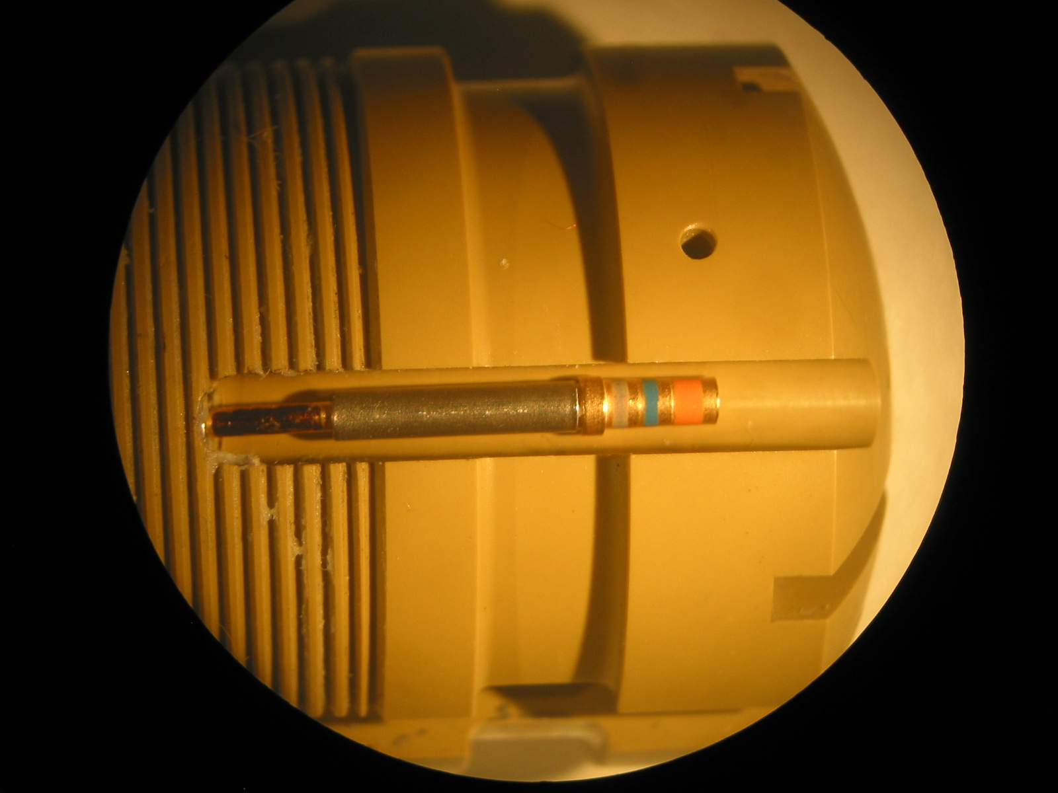
Bottom of socket Aligned with bottom of cross pin hole
Portion of Pin not engaged

