STEREO
IMPACT

Data Management Plan
input.doc
Version - B 10/01/2003

Peter Schroeder, UCB, IMPACT Operations / Data Manager

Document Revision Record
Vers. | Date | Description of Change | Approved By
A | 11/12/2002 | First Draft | -
B | 10/01/2003 | Expanded descriptions of software and calibration review processes. Data validation process expanded. Definitions supplied for acronyms, Beacon Data, Burst Data, and Level 0 Data. | -

Distribution List

Dave Curtis, UCB
Janet Luhmann, UCB
Davin Larson, UCB
Christopher Russell, UCLA
Andrew Davis, Caltech
Richard Mewaldt, Caltech
Donald Reames, GSFC
Christopher St. Cyr, CUA

Table of Contents

Document Revision Record i
Distribution List i
1. Overview 1
1.1 Introduction 1
1.2 Document Conventions 1
1.3 Applicable Documents 1
2. Data Management Plan Key Points 1
3. Data Products 2
4. Data Production Software 3
5. Software Configuration Management 4
6. Calibration Configuration Management 5
7. Data Production Software Timeline 6
8. Data Flow 6
APPENDICES 10
1. Beacon Data 10
2. Level 1 Data 11

1. Overview

1.1 Introduction
This document defines the STEREO/IMPACT Data Management Plan. This plan describes how the IMPACT team will produce, distribute, and archive Beacon Data, Level 1 Data, Level 2 Data, and Level 3 Data. Each of these forms of data will be defined within this document.

1.2 Document Conventions
In this document, TBD (To Be Determined) means that no information currently exists. TBR (To Be Resolved) means that a statement is preliminary. In either case, the acronym is typically followed by an indication of those responsible for providing the information, or the responsible institution.

1.3 Applicable Documents
These documents can be found on the Berkeley STEREO/IMPACT website: http://sprg.ssl.berkeley.edu/impact/dwc/. Others are currently available from the University of Maryland.

- Phase A Report/PAIP (Performance Assurance Implementation Plan)
- IMPACT Performance Requirements (http://sprg.ssl.berkeley.edu/impact/dwc/Specifications/)
3. SEP-SEPT Level 1 Data Format
(http://sprg.ssl.berkeley.edu/impact/peters/STEREO-ETKI-003.0.pdf)
4. SEP-LET Level 1 Data Format
(http://sprg.ssl.berkeley.edu/impact/peters/LET-Level1DataFormatB.pdf)
5. SEP-HET Level 1 Data Format
(http://sprg.ssl.berkeley.edu/impact/peters/HET-Level1DataFormatA.pdf)
6. SITLevel1DataFormat.PDF
(http://sprg.ssl.berkeley.edu/impact/peters/SIT-Level1DataFormatA.pdf)

2. Data Management Plan Key Points

The IMPACT/STEREO Data Management Plan is designed to provide a framework by which the IMPACT suite’s high quality data products will be produced as efficiently as possible. The central point of contact for all entities concerned with the production and release of data is the Operations/Data Manager (ODM) located at the IMPACT Payload Operations Center (POC) at the University of California-Berkeley (UCB). The ODM will be responsible for making sure that high quality data is produced and that dissemination of data is timely. Peter Schroeder, a person with much operations and data management experience in UCB-involved missions, is the IMPACT ODM.

The ODM single point of contact will simplify the flow of data for both persons outside the IMPACT team (the Mission Operations Center and STEREO Science Center, for example) and those within the IMPACT team. Outside entities will not need to deal with the details of the IMPACT instrument teams, and the instrument teams will have a single point of contact from which to retrieve and to which to deliver data.

Another important component of the plan is that different kinds of data products will be created allowing different user groups access the data at whatever level of sophistication needed. The IMPACT team will produce both high resolution data and key parameter data which will be useful depending on the user’s needs.

Finally, all data and data production software will be available to the public allowing for wide access and enhancing contributions from the entire scientific community.

3. Data Products

Four different types of data products will be produced. They are known as Beacon Data, Level 1 Data, Level 2 Data, and Level 3 Data. Each is described below.

The STEREO mission will produce Space Weather Beacon Data, a data set that will provide the scientific community with space weather information as measured by the STEREO observatories as quickly as possible. IMPACT will contribute plasma electron, magnetic field, and SEP key parameters to the STEREO Beacon Data set. Beacon Data are produced from Beacon Mode Telemetry. Beacon Mode Telemetry will be processed and the Beacon Data distributed by the STEREO Science Center (SSC). The software to process the IMPACT Beacon Mode Telemetry into Beacon Data will be provided by the IMPACT team in consultation with the SSC. Beacon Data will be in physical units. The IMPACT team will monitor Beacon Data quality and housekeeping data, and software and calibration updates will be provided by the IMPACT team to SSC as needed. IMPACT Beacon Data, Beacon Data processing software, and Level Zero data will be archived together by the SSC. There will be a nominal data set created from the Beacon Data merged and synchronized with PLASTIC Beacon Data at 1 minute resolution. A more complete description of the Beacon Data can be found in the Appendix.

Level 1 Data are highest time resolution data intended for detailed analysis. Access to the Level 1 Data will be through the POC web interface (to be described later) or the NASA archive. All data products from each IMPACT instrument will be included in physical units with the latest calibrations applied. Key ancillary data (e.g. magnetic field data) will also be merged in. When gaps appear in the Science Mode Telemetry, Beacon Data will be used to fill the gap time intervals. Also, Level 1 Data will be reprocessed if calibrations are changed. The instrument teams will provide software that will create Level 1 Data in “heritage” formats for efficiency in software development. Level 1 Data will be archived with format translators and/or software for reading the data files using computer languages such as Interactive Data Language (IDL), Fortran, and C. Burst Data will be included their own Level 1 Data files. Details on the Level 1 Data files can be found in the Appendix.

Level 2 Data are key parameter data consisting of one-minute averaged, synchronized sets containing the most often used quantities from IMPACT, SWAVES, and PLASTIC. The specific data to be included is TBD (IMPACT, SWAVES, PLASTIC teams). Both ASCII and binary flatfile formats containing Level 2 Data will be available. Level 2 Data will be processed and served by a webserver at the University of California – Los Angeles (UCLA). The webserver will include a data browser. The Level 2 Data set will be archived at the SSC.

Level 3 Data are value-added products that enhance access to and use of the other data products. Level 3 Data will include event lists with events such as shocks, interplanetary coronal mass ejections, and current sheet crossings. Level 3 Data will also include tables and plots contributed by team members. Level 3 Data will be available through UCLA’s Level 2 webserver or through links to team websites provided on the Level 2 webserver.

4. Data Production Software

The ODM at UCB will be the central dissemination point for data production software (See Figure 4-1). Each instrument team will provide the ODM Beacon Data production software, Level 1 Data production software, and instrument calibration data. All of the software and calibration data will then be forwarded to the SSC for archiving. Also, the SSC will use the Beacon Data production software and calibration data in producing Beacon Data. There will be one calibration data file for each IMPACT instrument which will be used in the production of both Beacon Data and Level 1 Data. Throughout the mission, changes in the Beacon Data production software, Level 1 Data production software, and calibration data by the instrument teams, which are approved by the review processes described below, will be sent to the ODM and will be forwarded by the ODM to the SSC. Instrument teams will provide complete Level 1 Data file descriptions and software tools with which to use the Level 1 Data to the POC. These file descriptions and software tools will be made available to the public through the SSC archive. Level 1 Data production software will be written to use Beacon Data to fill in data gaps.

The POC at UCB will host a web-based data tracking and retrieval system. This system will be the central mechanism for recording the status of and for
disseminating data products. The ODM will oversee this system. Parts of this system will be password-protected so that unvalidated data is not released to the public.

Level 2 Data production software, Data access, and Data archiving will be overseen by UCLA. Instrument teams will collaborate with UCLA to produce Level 2 Data production software.

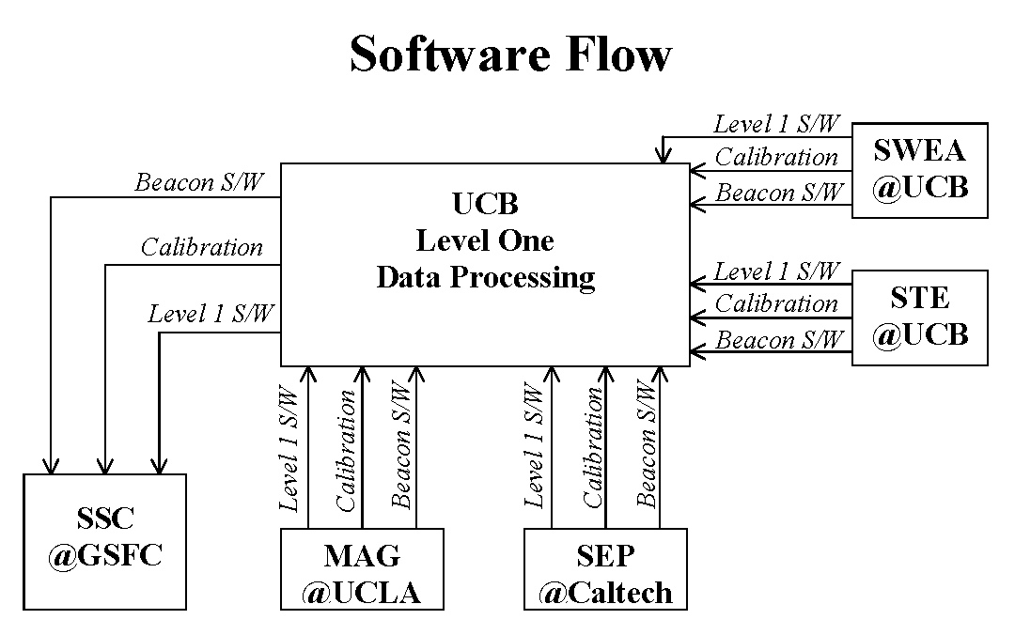

Figure 4-1

5. Software Configuration Management

The IMPACT instrument teams will provide routines to produce Beacon Data and Level 1 Data from the IMPACT Level 0 Data. Level 0 Data is created at the MOC and is defined in the STEREO MOC-POC ICD. Each data processing routine provided by the instrument teams to produce Beacon, Level 1 Data, or Level 2 Data will be associated with a software version number. Each time that a routine is revised, that routine’s software version number will increment by one. Initially, all routines will have a software version number of 1. Every data product created by one of these routines will include a field for the software version number which will indicate the number of the software revision used to create that product. In addition, each Level 2 Data product will also include the software revision number from the Level 1 Data product used to generate the Level 2 Data.

When an instrument team revises a Beacon Data, Level 1 Data, or Level 2 Data processing routine, the revised routine must undergo a review process to demonstrate that the revised routine performs correctly.

During the review of a revision of Beacon Data or Level 1 Data processing software, the ODM at the IMPACT POC will use the revised routine to produce data products for at least three days of data. The dates that will be processed will be chosen for their differing characteristics (ie. one date during an ICME event, one date during which no events occur, one date within the Earth’s magnetosphere, etc.). A committee consisting of the ODM, the Co-Investigator in charge of the instrument, and ad hoc members chosen by the ODM and Co-Investigator such as instrument engineers and software developers will determine the dates to be tested and whether the data products created with the revised routine are correct. If the products created are not correct, the revision will be rejected. If the committee determines that the routine is functioning correctly, the ODM will archive the previous version of the routine, keeping it available for retrieval by team members and the public by a web interface from UCB. The new routine will replace the previous routine in the data processing stream at the POC (for Level 1 software) or at the SSC (for Beacon Data software). Data products created by the routine will be reprocessed from the beginning of the mission to the present by the ODM at UCB for Level 1 Data or by personnel at the SSC for Beacon Data. These data products will replace the products created by the old routine. UCLA will be notified of the updated data products so that new Level 2 Data will be generated.

During the review of a revision of Level 2 Data processing software, the personnel in charge of Level 2 Data processing at UCLA will use the revised routine to produce data products for at least three days of data. The dates that will be processed will be chosen for their differing characteristics (ie. one date during an ICME event, one date during which no events occur, one date within the Earth’s magnetosphere, etc.). A committee consisting of the person in charge of Level 2 Data processing at UCLA, the Co-Investigator in charge of the instrument, and ad hoc members chosen by the Level 2 Data processor and Co-Investigator such as instrument engineers and software developers will determine the dates to be tested and whether the data products created with the revised routine are correct. If the products created are not correct, the revision will be rejected. If the committee determines that the routine is functioning correctly, the new routine will replace the previous routine in the data processing stream at UCLA. The new routine will also be given to the SSC for archiving. Data products created by the routine will be reprocessed from the beginning of the mission to the present by UCLA. These data products will replace the products created by the old routine. The ODM at UCB will be notified of the software revision so that he may update documentation kept at the POC.

A publicly accessible web page maintained at UCB by the ODM will contain a history of software revisions. The web page will indicate the latest software version number for each routine, the dates that revisions, past and present, were approved, and notes on the revisions made to the software.

6. Calibration Configuration Management

The IMPACT instrument teams will provide calibration data for the production Beacon Data and Level 1 Data from the IMPACT Level 0 Data. Each calibration data file provided by the instrument teams will be associated with a calibration version number. Each time that a calibration data file is revised, that file’s calibration version number will increment by one. Initially, all calibration data files will have a calibration version number of 1. Every data product created using one of these calibration data files will include a field for the calibration version number which will indicate the number of the calibration revision used to create that product. In addition, each Level 2 Data product will also include the calibration revision number from the Level 1 Data product used to generate the Level 2 Data.

When an instrument team revises a calibration data file, the revised calibration data file must undergo a review process to demonstrate that the revised calibration data file performs correctly. During the review, the ODM at the IMPACT POC will use the calibration data file to produce Level 1 and Beacon Data products for at least three days of data. The dates that will be processed will be chosen for their differing characteristics (ie. one date during an ICME event, one date during which no events occur, one date within the Earth’s magnetosphere, etc.). A committee consisting of the ODM, the Co-Investigator in charge of the instrument, and ad hoc members chosen by the ODM and Co-Investigator such as instrument engineers and software developers will determine the dates to be tested and whether the data products created with the revised calibration data file are correct. If the products created are not correct, the revision will be rejected. If the committee determines that the products are correct, the ODM will archive the previous version of the calibration data file, keeping it available for retrieval by team members and the public by a web interface from UCB. The new calibration data file will replace the previous file in the data processing stream at the POC (for Level 1 processing) and at the SSC (for Beacon Data processing). Data products created using the calibration data file will be reprocessed for the dates affected by the revision by the ODM at UCB for Level 1 Data or by personnel at the SSC for Beacon Data. These data products will replace the products created using the old calibration data. UCLA will be notified of the updated data products so that new Level 2 Data will be generated.

A publicly accessible web page maintained at UCB by the ODM will contain a history of calibration revisions. The web page will indicate the latest calibration version number for each calibration data file, the dates that revisions, past and present, were approved, and notes on the revisions made to the calibration data files.

7. Data Production Software Timeline

Beacon Data production software and initial calibrations will be delivered to the ODM and forwarded to the SSC one month before the first IMPACT simulation producing Beacon Mode Telemetry. Level 1 Data production software will be delivered to the ODM one month before the next IMPACT simulation producing Beacon Mode Telemetry. The due date for delivery of Level 2 Data production software is TBD (UCLA and IMPACT, SWAVES, and PLASTIC teams).

8. Data Flow

During normal operations, the ODM will conduct teleconferences with the instrument teams as needed to deal with issues regarding data production. Data issues will also be discussed at monthly IMPACT telecons and at Team meetings.

The SSC will receive Level 0 Data and ancillary products from the MOC at APL. SSC will process the Beacon Data with the Beacon Data production software and calibration data. The SSC will make the Beacon Data available to the public and archive it (See Figure 8-1).
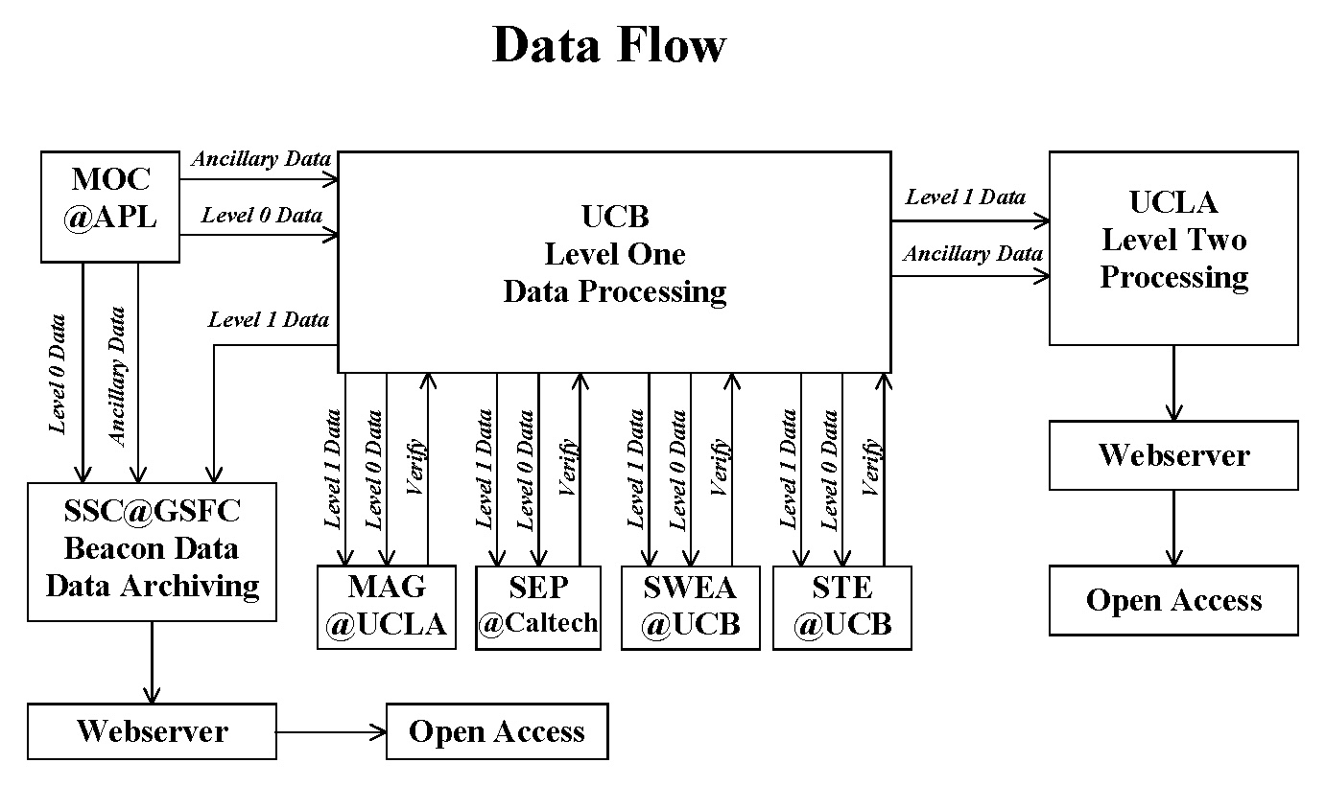

Figure 8-1

The POC will receive Level 0 Data and ancillary products from the MOC and will produce preliminary Level 1 Data with the Level 1 Data production software and calibration data. The preliminary Level 1 Data along with the Level 0 Data and ancillary products will be available to the instrument teams through the POC web interface. At this point, the POC web interface will designate this Level 1 Data as “preliminary.” PLASTIC and SWAVES team members will have access to preliminary Level 1 Data for early interpretation of their data. Production of the preliminary Level 1 Data will take a maximum of 24 hours upon receipt of definitive Level 0 Data. Instrument teams will have up to 60 days to confirm the validity of the preliminary Level 1 Data or to provide corrected Level 1 Data production software and/or calibration data with which to produce corrected Level 1 Data. The procedures for revision of data processing software and calibration data have previously been discussed. The Co-Investigators in charge of the instrument teams are responsible for the validation of their instruments’ Level 1 Data. The Co-Investigators, in consultation with other members of their instrument teams such as instrument engineers, will check the data for correctness. The Co-Investigator will indicate that a specific Level 1 Data file is valid through a password-protected web interface hosted at the POC. Once the Level 1 Data is validated, it will be marked as “validated” in the POC web interface and made publicly available. UCLA and the SSC will use the POC web interface to retrieve the validated Level 1 Data. The SSC will archive the Level 1 Data.

UCLA will use the Level 1 Data and Level 2 Data production software to produce the IMPACT Level 2 Data (See Figure 8-2). UCLA will also retrieve data from the SWAVES and PLASTIC teams upon their agreement and produce Level 2 Data for those teams. UCLA will have 2 weeks after receipt of the Level 1 Data to produce Level 2 Data. UCLA will make the Level 2 Data available to the STEREO teams and the public through their web interface. UCLA’s web interface will include a browser allowing users to quickly identify data and time intervals of interest. Level 2 Data will be available in both ASCII and binary flatfile formats.
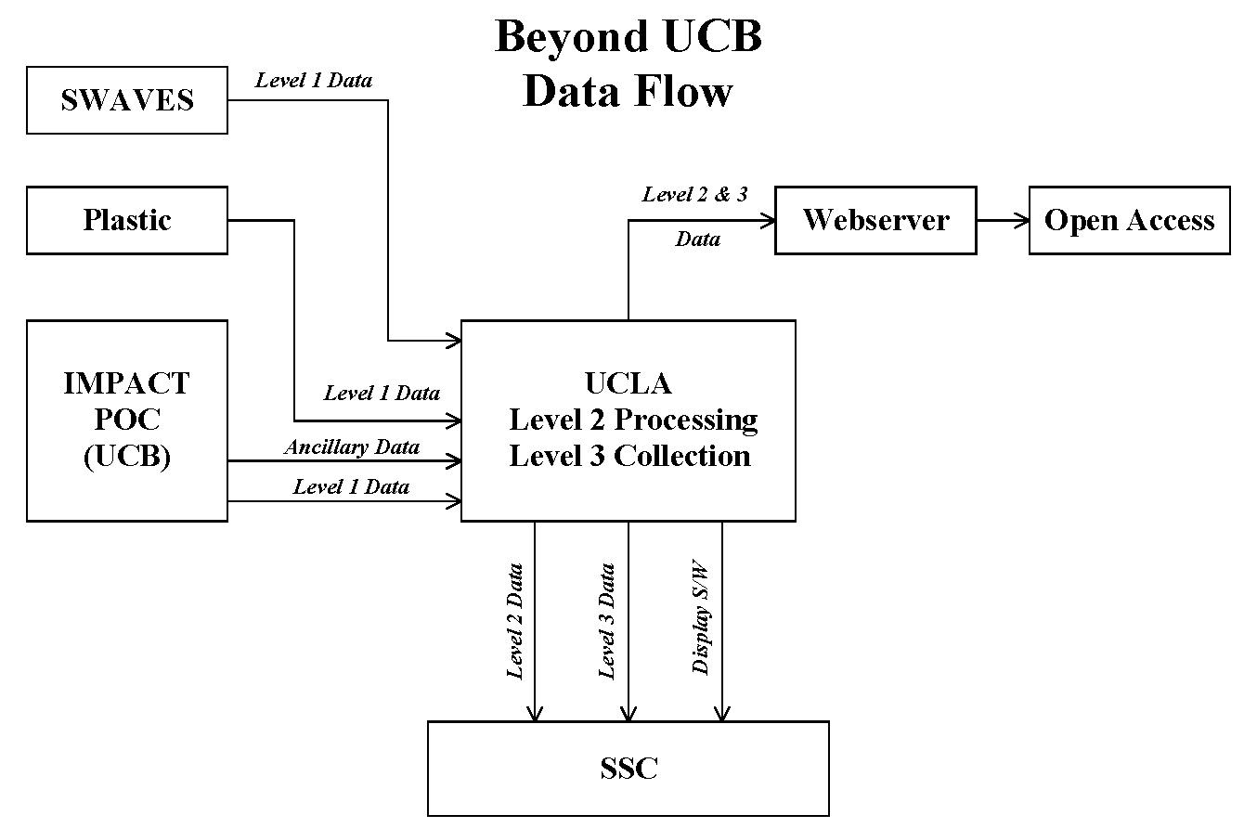

Figure 8-2

UCLA will create Level 3 Data with input from the IMPACT, SWAVES, and PLASTIC teams. Level 3 Data will be available one month after receipt of the Level 1 Data. UCLA will make the Level 3 Data available to the STEREO teams and the public through their web interface (See Table 8-1).

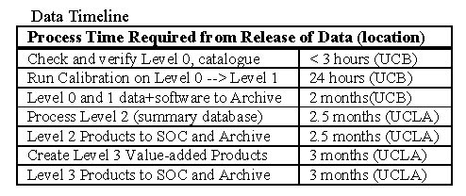
Table 8-1

APPENDICES

1. Beacon Data

Exact format of the Beacon Mode Telemetry packet is TBD (UCB). The following data will be included in the Beacon Mode Data set:

MAG:
B vectors, 3 samples/minute in spacecraft coordinates. Beacon Data Processing software will transform the data into other coordinate systems as well (ie. STEREO Solar Orbital and RTN).

STE:
Electron flux given in 2 look directions at 8 energies and at 16 samples/minute.

SWEA:
Moments (electron density, bulk velocity, temperature) at 13 samples/minute.
Pitch Angle Distributions at 2 energies in 12 look directions and 24 samples/minute.

SEP:
SEP status

SEP-SEPT:
Electron flux at 2 energies in 4 look directions averaged over 1 minute.
Electron flux at 2 energies summed over 4 look directions averaged over 1 minute.
Ion flux at 2 energies in 4 look directions averaged over 1 sample/minute.
Ion flux at 2 energies summed over 4 look directions averaged over 1 sample/minute.
SEPT status.

SEP-LET:
Proton flux at 1 energy in 2 look directions averaged over 1 minute.
Proton flux at 1 energy summed over all look angles averaged over 1 minute.
He flux at 2 energies in 2 look directions averaged over 1 minute.
He flux at 1 energy summed over all look angles averaged over 1 minute.
3He flux at 2 energies summed over all look angles averaged over 1 minute.
CNO flux at 3 energies summed over all look angles averaged over 1 minute.
Fe flux at 4 energies summed over all look angles averaged over 1 minute.
Livetime counter.
H/He efficiency.
Z efficiency.
L1A-th.
L1B-th.
L2L2th.

SEP-HET:
Electron flux at 1 energy averaged over 1 minute.
Proton flux at 3 energies averaged over 1 minute.
He flux at 3 energies averaged over 1 minute.
CNO flux at 2 energies averaged over 1 minute.
Fe flux at 1 energy averaged over 1 minute.
Livetime counter.
Stop efficiency.
Penetration efficiency.
HET status.

SEP-SIT:
HE flux at 4 energies averaged over 1 minute.
CNO flux at 4 energies averaged over 1 minute.
Fe flux at 4 energies averaged over 1 minute.

IMPACT (in general):
Instrument status.
Packet overhead.

2. Level 1 Data

SEP:
Please see the following documents regarding the Level 1 Data products for SEP instruments available at the website indicated above:
For SEP-SEPT, STEREO-ETKI-003.0.pdf
For SEP-LET, LET-Level1DataFormatA.pdf
For SEP-HET, HET-Level1DataFormatB.pdf
For SEP-SIT, SITLevel1DataFormat.doc

MAG:
File format: Binary flatfile with ASCII header
Time convention: TBD (UCLA)
Quantities included: Bx, By, Bz, B (all in nanoteslas)
Coordinate system: Spacecraft coordinates and STEREO Solar Orbital Coordinates
Time resolution: 0.1 seconds

SWEA:
File format: CDF
Time convention: Seconds since Jan 1, 1970
Quantities included:
Pitch angle distributions [NE, NA] in flux units
Look angles [NA] in degrees
Energy steps [NE] in eV
Density in 1/cc
Velocity in km/s
Temperature in eV
Heat Flux along B in eV*km/s/cc
SC Potential in volts
Magnetic field vector in nT
NE = 16, NA = 8 TBR (UCB)
Coordinate system: STEREO Solar Orbital Coordinates
Time resolution: TBD (UCB)

STE:
File format: CDF
Time convention: Seconds since Jan 1, 1970
Quantities included:
Electron Flux [NE, NA] in units of flux
Look angles [NA] in degrees
Energy steps [NE] in eV
Magnetic field vector in nT
Miscellaneous housekeeping data and instrument settings
Possibly, Pitch angle distributions [NE, NPad] in units of flux (TBR UCB)
NE = 16, NA = 80, NPad = 10 TBR (UCB)
Coordinate system: STEREO Solar Orbital Coordinates
Time resolution: TBD (UCB)

